Project Design Phase-II TechnologyStack(Architecture&Stack)

Date | 31 October 2025
TeamID | NM2025TMID01076
ProjectName | Laptop Request Catalog Item
Maximum Marks | 4Marks

TechnicalArchitecture:
TheDeliverableshallincludethearchitecturaldiagramasbelowandtheinformationasperthetable1&table2
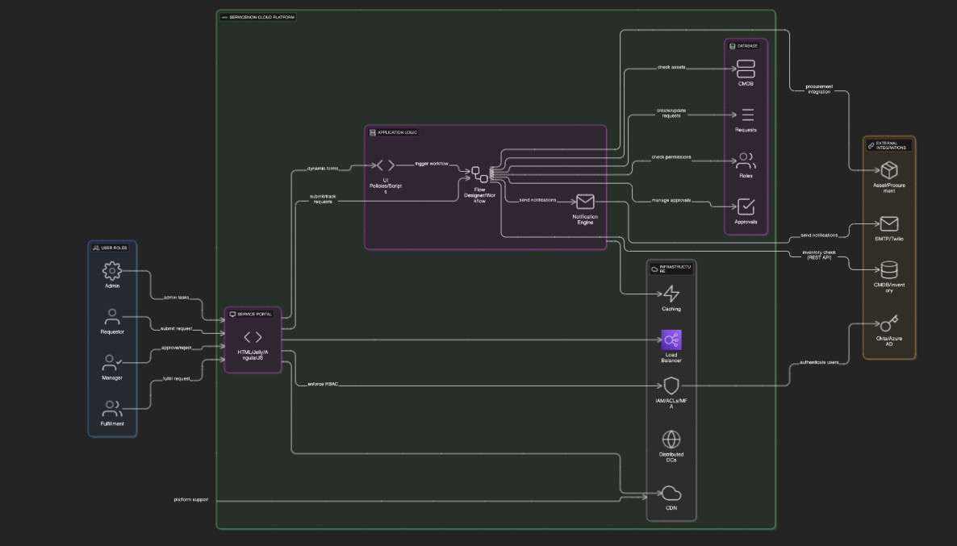

Table-1:Components&Technologies:

S.No | Component | Description | Technology
1. | UserInterface | Web-basedServiceNowServiceCatalogportalto submit requests | ServiceNow UI Framework (HTML, Jelly,AngularJSinsideServiceNow)
2. | ApplicationLogic-1 | DynamicformbehaviorusingUIPoliciesandClient Scripts | ServiceNowServer-sidescripts (JavaScript, Glide API)
3. | ApplicationLogic-2 | Workflowautomationandapproval processing | ServiceNowFlowDesigner/Workflow Engine
4. | ApplicationLogic-3 | Emailnotificationandalertlogic | ServiceNowNotificationEngine
5. | Database | Storeslaptoprequest,approval,anduserdata | ServiceNowCMDB,TaskandRequest tables (MySQL-based backend)
6. | ExternalAPI-1 | IntegrationtofetchlaptopavailabilityfromCMDB | ServiceNowRESTAPIorOOTBCMDB APIs
7. | Infrastructure(Server/Cloud) | ServiceNowPlatformhostedonCloud | ServiceNowCloudSaaSPlatform
Table-2:ApplicationCharacteristics:

S.No | Characteristics | Description | Technology
1. | Open-SourceFrameworks | ServiceNow platform leverages open-source componentslikeAngularJSforUI,andJavaScript  forclient/serverscripting. | AngularJS,JavaScript
2. | SecurityImplementations | Role-based access control, multi-factor authentication,encryptionofdataatrestandin  transit,OWASPbestpractices. | ServiceNowIAM,HTTPS,TLS,ACLs, OAuth2
3. | ScalableArchitecture | ServiceNow’s multi-tenant cloud architecture supportsscalabilitywithmodularcomponentsand APIs following microservices principles. | ServiceNowCloudPlatform,REST APIs
4. | Availability | Highavailabilitywithgeographicallydistributed  datacenters,automatedfailover,scheduled maintenance windows. | ServiceNowCloudInfrastructure,Load Balancers
5. | Performance | Optimizedworkflows,cachingmechanismswithin  ServiceNow,andCDNservicesforstaticassetsto ensure low latency and high throughput. | ServiceNowCachingLayer,CDN (Akamaized or similar)

